Physical exercises you can do at home (www.nhs.uk)
Warm up properly before exercising to prevent injury and make your workouts more effective.
This warm-up routine should take at least 6 minutes. Warm up for longer if you feel the need.

March on the spot: keep going for 3 minutes
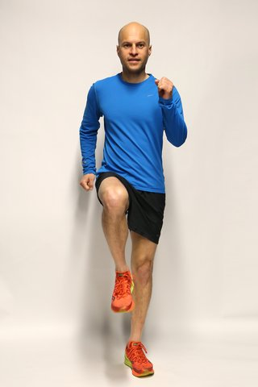
Start off marching on the spot and then march forwards and backwards. Pump your arms up and down in rhythm with your steps, keeping the elbows bent and the fists soft.

Heel digs: aim for 60 heel digs in 60 seconds
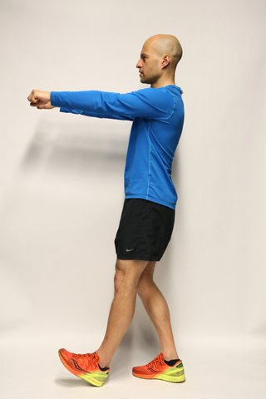
For heel digs, place alternate heels to the front, keeping the front foot pointing up, and punch out with each heel dig. Keep a slight bend in the supporting leg.

Knee lifts: aim for 30 knee lifts in 30 seconds
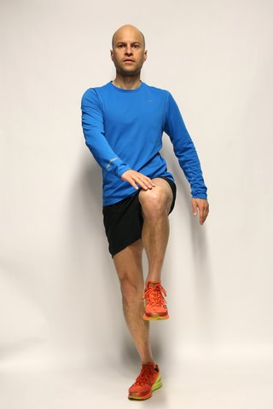
To do knee lifts, stand tall and bring up alternate knees to touch the opposite hand. Keep your abs tight and back straight. Keep a slight bend in the supporting leg.

Shoulder rolls: 2 sets of 10 repetitions
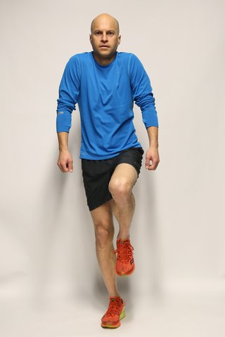
For shoulder rolls, keep marching on the spot. Roll your shoulders forwards 5 times and backwards 5 times. Let your arms hang loose by your sides.

Knee bends: 10 repetitions
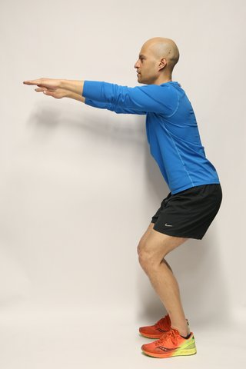
To do knee bends, stand with your feet shoulder-width apart and your hands stretched out. Lower yourself no more than 10cm by bending your knees. Come up and repeat.

10-minute home cardio workout

Burn calories, lose weight and feel great with this 10-minute home cardio workout routine for aerobic fitness.
If you have a skipping rope, you can swap one of the exercises with a 60-second burst of skipping.
This 10-minute cardio workout counts towards your recommended 150 minutes of aerobic activity every week.
Before you begin, warm up with a 6-minute warm-up routine.

Rocket jumps: 2 sets of 15 to 24 repetitions (reps)
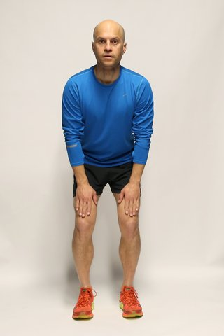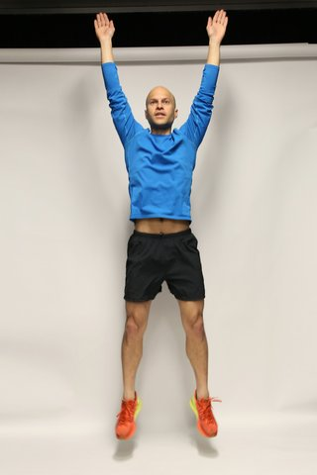
For rocket jumps, stand with your feet hip-width apart, legs bent and hands on your thighs.
Jump up, driving your hands straight above your head and extending your entire body. Land softly, reposition your feet and repeat.
For more of a challenge, start in a lower squat position and hold a weight or a bottle of water in both hands at the centre of your chest.
- Recovery: walk or jog on the spot for 15 to 45 seconds.

Star jumps or squats: 2 sets of 15 to 24 reps
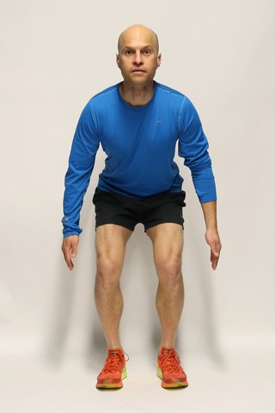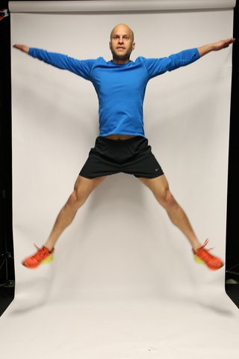
To do a star jump, stand tall with your arms by your side and knees slightly bent.

Jump up, extending your arms and legs out into a star shape in the air.

Land softly, with your knees together and hands by your side.

Keep your abs tight and back straight during the exercise.

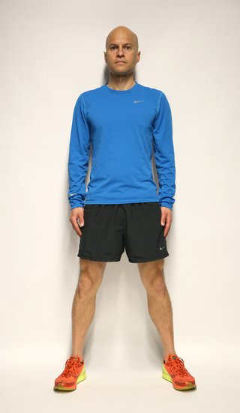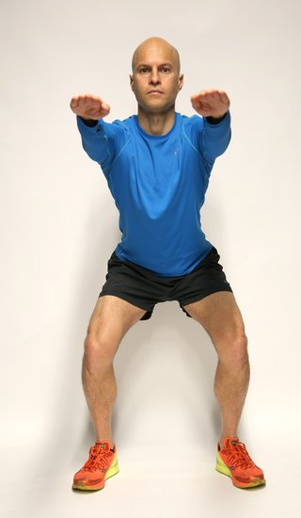
Squats
As a less energetic alternative, do some squats. Stand with your feet shoulder-width apart and your hands down by your sides or stretched out in front for extra balance.
Lower yourself by bending your knees until they're nearly at a right angle, with your thighs parallel to the floor. Keep your back straight and don't let your knees extend over your toes.
- Recovery: walk or jog on the spot for 15 to 45 seconds.

Tap backs: 2 sets of 15 to 24 reps
To start tap backs, step your right leg back and swing both arms forward, then repeat with the opposite leg in a continuous rhythmic movement.
Look forward and keep your hips and shoulders facing forward. Don't let your front knee extend over your toes as you step back.
For more of a challenge, switch legs by jumping (also known as spotty dog), remembering to keep the knees soft as you land. Your back heel needs to be off the floor at all times.
Recovery: walk or jog on the spot for 15 to 45 seconds.

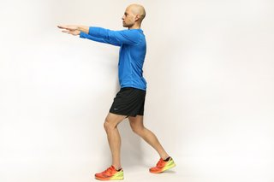

Burpees: 2 sets of 15 to 24 reps
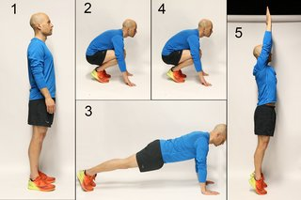
To do a burpee from a standing position (1), drop into a squat with your hands on the ground (2).
Kick your feet back into a push-up position (3). Jump your feet back into a squat (4) and jump up with your arms extending overhead (5).
For an easier burpee, don't kick out into the push-up position and stand up instead of jumping.

10-minute legs, bums and tums home workout

Tone up, firm up and burn fat from your tummy, hips, thighs and bottom with this 10-minute legs, bums and tums (LBT) home workout.
This LBT exercise routine counts towards your recommended weekly activity target for strength.
Before you begin, warm up with a 6-minute warm-up. After your workout, cool down with a 5-minute stretch.

Squats: great for firm bums and thighs
Do 2 sets of 15 to 24 repetitions (reps).
Stand with your feet shoulder-width apart and your hands down by your sides, or stretched out in front for extra balance
Lower yourself by bending your knees until they're nearly at a right angle, with your thighs parallel to the floor
Tip: Keep your back straight and don't let your knees extend over your toes.

Lunges: great for firm bums and thighs
Do 1 set of 15 to 24 reps with each leg.
Stand in a split stance, with your right leg forward and left leg back. Slowly bend the knees, lowering into a lunge until both legs are nearly at right angles. Keeping the weight on your heels, push back up to starting position
Tip: Keep your back straight and don't let your knees extend over your toes
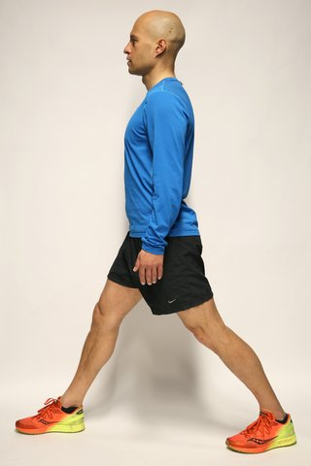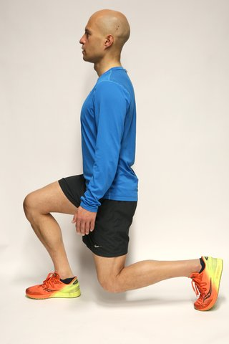
.

Calf raises: great for shapely legs and calves
Do 2 sets of 15 reps.
Place your hands on a wall or chair stability. Stand straight, but avoid locking your knees
Slowly move onto your toes, lifting your heels off the ground, and then slowly lower your heels back down
Tip: For more of a challenge, do these calf raises away from the wall and with a weight in each hand, such as 2 water bottles.
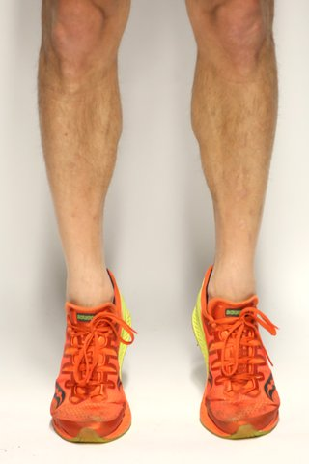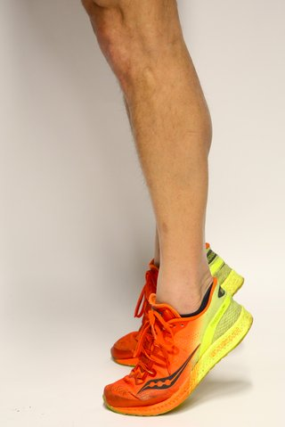

Bridges: great for firm bums
Do 2 sets of 15 to 20 reps.
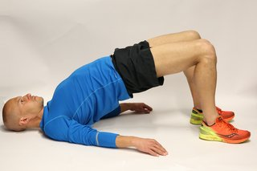Lie on your back with your knees bent and heels close to your bottom. Your feet should be shoulder-width apart and flat on the floor. Raise your hips up to create a straight line from knees to shoulders. As you come up, tighten your abdominal and buttock muscles.
Tip: Don't let your knees point outwards.

Stomach crunches: great for strong abs
Do 2 sets of 15 to 24 reps.
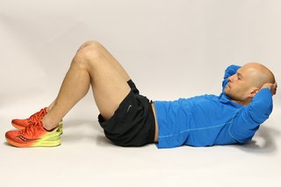Lie down on your back, knees bent and hands behind your ears. Keeping your lower back pressed into the floor, raise your shoulder blades no more than 3 inches off the floor and slowly lower down
Tip: Don't tuck your neck into your chest as you rise and don't use your hands to pull your neck up.

Obliques: great for toning love handles
Do 1 set of 12 to 24 reps on each side.
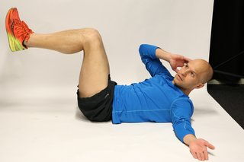Lie down on your back with your knees bent and together, and feet off the floor. Place your right hand behind your right ear and extend the left arm out. Keeping your lower back pressed into the floor, lift your shoulder blades off the floor and curl your upper body diagonally across your chest towards your left knee and lower down

Back raises: great for good posture
Do 2 sets of 15 to 24 reps.
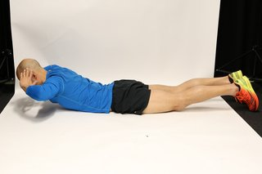Lie down on your chest and place your hands by your temples or extended out in front for more of a challenge. Keeping your legs together and feet on the ground, raise your shoulders off the floor no more than 3 inches and slowly lower down
Tip: Keep a long neck and look down as you perform the exercise.
Now cool down with this 5-minute stretch and cool-down routine.

5-minute Stretch and Cool Down Routine

Use this routine to cool down after a workout to gradually relax, improve flexibility and slow your heart rate.
These gentle stretches should take about 5 minutes. Spend more time on them if you feel the need.

Buttock stretch – hold for 10 to 15 seconds
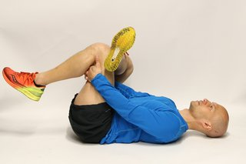
To do a buttock stretch:
- Lie on your back and bring your knees up to your chest.
- Cross your right leg over your left thigh.
- Grasp the back of your left thigh with both hands.
- Pull your left leg towards your chest.
- Repeat with the opposite leg.

Hamstring stretch – hold for 10 to 15 seconds
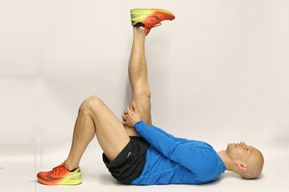
To do a hamstring stretch:
- Lie on your back and raise your right leg.
- Hold your right leg with both hands, below your knee.
- Keeping your left leg bent with your foot on the floor, pull your right leg towards you keeping it straight.
- Repeat with the opposite leg.

Inner thigh stretch – hold for 10 to 15 seconds
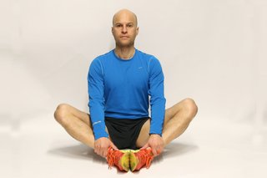
For the inner thigh stretch:
- Sit down with your back straight and your legs bent.
- Put the soles of your feet together.
- Holding on to your feet, try to lower your knees towards the floor.

Calf stretch – hold for 10 to 15 seconds
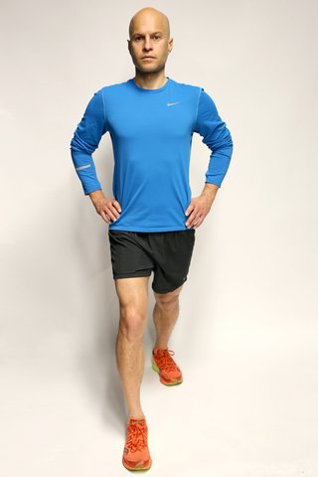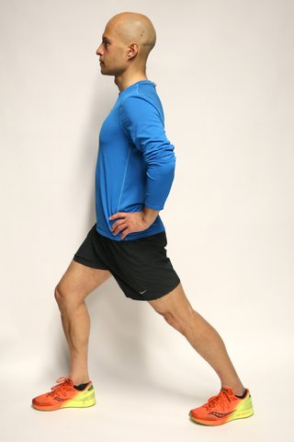
For the calf stretch:
- Step your right leg forward, keeping it bent, and lean forwards slightly.
- Keep your left leg straight and try to lower the left heel to the ground.
- Repeat with the opposite leg.

Thigh stretch – hold for 10 to 15 seconds
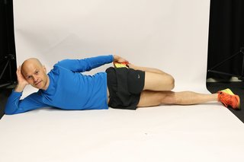
To do a thigh stretch:
- Lie on your right side.
- Grab the top of your left foot and gently pull your heel towards your left buttock to stretch the front of the thigh.
- Keep your knees touching.
- Repeat on the other side.

